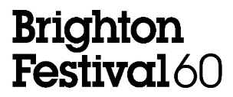

FOR IMMEDIATE RELEASE – THURSDAY 9 APRIL

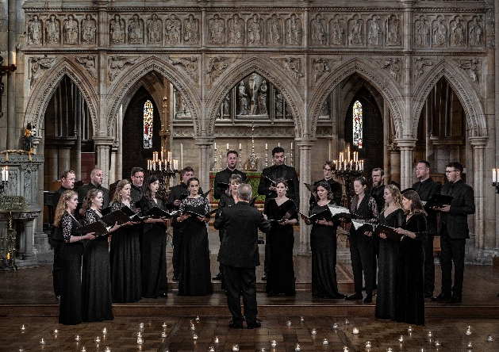
Brighton Festival’s 2026 classical programme celebrates 400 years of musical excellence

For its landmark 60th edition, Brighton Festival presents a vast classical music programme that spans four hundred years from Monteverdi and Bach to Shostakovich and British composer Anna Meredith. The programme ranges from large-scale orchestral performances to intimate recitals, by acclaimed artists and ensembles from around the world.

Opening the classical programme across Brighton Festival’s first weekend, leading string quartets Chiaroscuro Quartet and Consone Quartet unite for a one-off performance at Glyndebourne Opera House on Sunday 3 May. They will each perform masterpieces by Haydn and Mozart individually, before joining forces for Mendelssohn’s Octet. On Bank Holiday Monday (4 May), a bold staging of Bach’s St John Passion is performed in Brighton Dome’s Concert Hall by Britten Sinfonia with Brighton Festival Chorus and Youth Choir and young international soloists from William Christie’s Les Arts Florissants and Le Jardin des Voix. This Brighton Festival Exclusive of the Passion is made more immediate by being sung in English and in parts from memory, with the choirs moving through the auditorium to dissolve the boundaries between audience and performers.

In another Brighton Festival Exclusive, Brighton Philharmonic Orchestra accompanies a screening of William Kentridge’s animated film Oh To Believe in Another World with a rendition of Shostakovich’s powerful Symphony No. 10 in Brighton Dome Concert Hall on 17 May. Using collage, puppets and masked actors, Kentridge’s film, which he will introduce himself, depicts the decades from the 1917 Russian revolution to 1953, the year of Stalin’s death, inspired by Shostakovich’s symphony.

London Symphony Orchestra returns to Brighton Festival on 8 May under Chief Conductor Sir Antonio Pappano. The Orchestra presents works from Beethoven’s Piano Concerto No. 3 and Tchaikovsky’s Symphony No. 6, joined by leading pianist Denis Kozhukhin. BAFTA-winning actor Miranda Richardson reads from Dame Harriet Walter’s new book She Speaks! at Shakespeare’s Sisters (10 May, Brighton Dome Concert Hall). The book gives voice to Shakespeare’s most recognisable female characters in original verse. Also featuring performances by soprano Sophie Bevan and pianist Christopher Glynn, this event interweaves music and words to explore how Shakespeare’s women have inspired the arts across centuries.

On 20 May, internationally acclaimed countertenor Iestyn Davies and award-winning harpist Oliver Wass present a captivating programme traversing 400 years of music and song. Performing in the Regency splendour of Brighton’s Royal Pavilion Music Room, Davies and Wass encompass Monteverdi to Anna Meredith by way of Handel and Schubert. Award-winning chamber choir Tenebrae return on 23 May with A Celestial Gift, a programme of five centuries of sacred choral music in Latin, English and Russian, including Allegri’s Miserere, Holst’s Nunc dimittis and Rachmaninoff’s Cherubic Hymn.

Brighton and East Sussex Youth Orchestra (11 May, Brighton Dome Concert Hall) are joined by International Piano Competition winner Curtis Phill Hsu for their annual Brighton Festival performance. The Orchestra will perform Rachmaninoff’s second Piano Concerto, famously featured in the film Brief Encounter, among other orchestral works from the Romantic period to the present day.

Throughout the Festival, a series of Lunchtime concerts take place in Brighton Dome’s Studio Theatre and Concert Hall (5–20 May). The series features performances from new and emerging international and UK artists, including Delphine Trio, Sherri Lun and the Jerwood Glyndebourne Young Singers, with tickets at £10.

Brighton Festival 2026 runs from 1-25 May. For more information and to book tickets, visit brightonfestival.org.

ENDS

Notes to Editors

Images can be accessed here:
https://tinyurl.com/bf26classical

The full Brighton Festival press pack can be accessed here:
https://tinyurl.com/bf26presspack

For press enquiries or interview requests please contact:

Katie Fowler, Communications Manager, Brighton Dome & Brighton Festival – katie.fowler@brightondome.org
Alex Jacobs, Communications Officer, Brighton Dome & Brighton Festival – alex.jacobs@brightondome.org

Key facts about Brighton Festival 2026

- 60th edition of Brighton Festival
- 105 events, exhibitions and installations from 1-25 May 2026
- The first-ever Brighton Festival Production, plus another 27 commissions, premieres and exclusives
- The 40th Children’s Parade, and 10th edition of Our Place
- Under 30s can access discounted tickets to over 30 events
- 25 free events, performances and workshops
- 60 performances with tickets £15 or less, plus £10 Festival Standbys for concession groups on most events. The Pay it Forward scheme also supports free ticket vouchers for community organisations.

About Brighton Festival

Brighton Festival was established in 1967 and is the largest annual curated multi-arts festival in England. For three weeks and four weekends each May, it brings a celebration of music, theatre, dance, visual art, film, literature, debate, outdoor and community events to the beautiful Brighton Dome spaces and to familiar and unusual locations in Brighton & Hove and further afield.

Brighton Festival has become one of the city’s most enduring symbols of inventiveness. Renowned for its pioneering spirit and experimental reputation, Brighton Festival’s ambitious, daring programming celebrates its home city as a hub for cultural innovation, collaboration and artistic experimentation and attracts some of the most celebrated and innovative artists and companies from the UK and around the world. Brighton Festival 2026 is its 60th edition and marks the start of a new era, with the first staging of original work produced in-house.

Website: brightonfestival.org
TikTok: @brightonfestival
Instagram: @brightonfestival
Facebook: brightonfestival
X/Twitter: @brightfest

Brighton Festival 2026 supporters

Brighton Festival 2026 is indebted to the steadfast support of funders Brighton & Hove City Council and Arts Council England; Principal Supporter The Pebble Trust; Major Sponsor Mayo Wynne Baxter; Higher Education Partner University of Sussex; and all sponsors, patrons, members and supporters.

Kohlhaas is supported by Louise & Jamie Arnell. The Children’s Parade is supported by Brighton Girls and Jumpin Fun. Soft Machines is supported by the Henry Moore Foundation. Chiaroscuro and Consone Quartets are supported by Margaret Polmear. Comedy and Create Music events and the Brighton Dome & Brighton Festival membership scheme are supported by Mayo Wynne Baxter. Our Place is supported by Pembroke. Michael Rosen & MC Grammar: Ridiculous Raps & Rhymes is supported by Brighton College Prep School. London Symphony Orchestra is supported by Professor David Gann CBE FREng. Festival of Ideas is in collaboration with University of Sussex. Thikra: A Night of Remembering is supported by Dishoom Permit Room.

