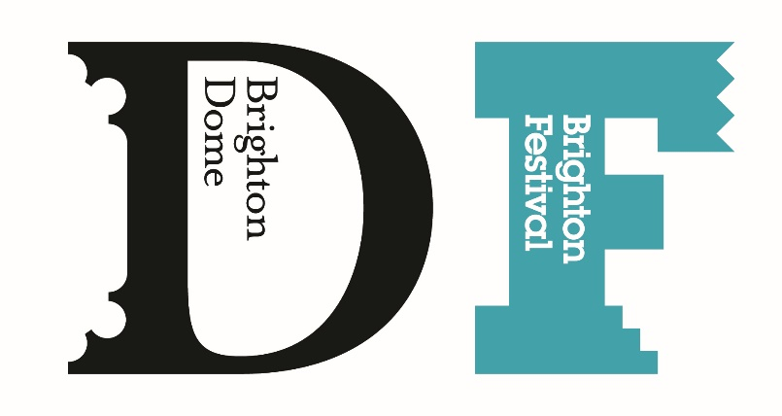

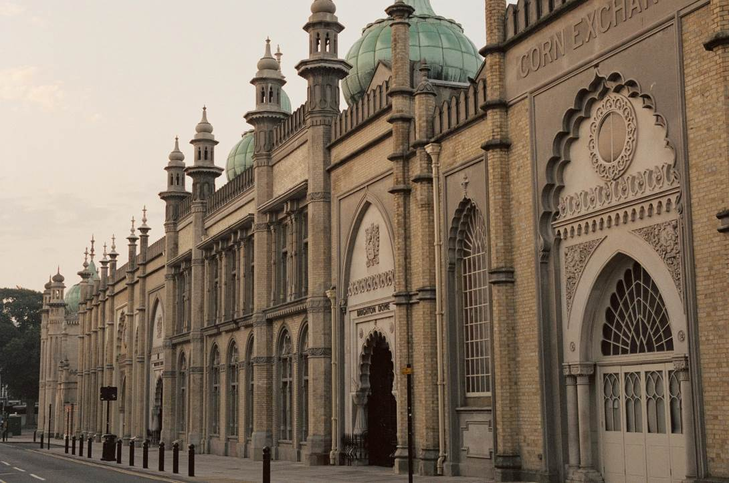

Brighton Dome and Brighton Festival
How to get here and
Blue Badge parking

Getting Here

For full details and maps of how to reach us please see our website http://brightondome.org/your_visit/getting_here/
Alternatively you can plan your journey by car or public transport using a journey planner website such as
- Trains http://www.southwesttrains.co.uk/
- Car google map to Brighton Dome simply enter your postcode and ours which is BN1 1UG to get directions
- Buses http://www.buses.co.uk/

Trains
- Brighton railway station is 800 metres which is a 10-minute walk to Brighton Dome. The map below shows 2 routes from the station both are step free
- For information and the accessibility of the station see:
- http://www.nationalrail.co.uk/stations/sjp/BTN/stationOverview.xhtml
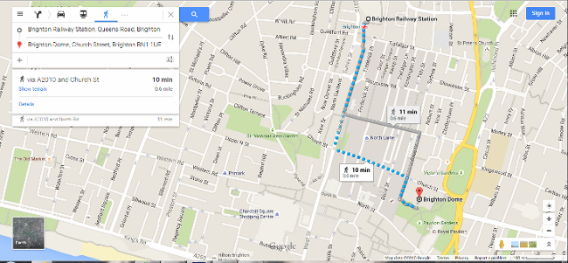
- There are fast, regular services into Brighton from London (journey time just 52 minutes from Victoria or 56 minutes from London Bridge) and from along the coast. For up-to-the-minute travel information, visit Southern Railway or call National Rail Enquiries on 08457 484950

Route from Brighton train station to Brighton Dome – step free

Buses
- Buses have easy access for boarding and space for 1 wheelchair or any mobility vehicle with a parking brake. Scooters are not permitted. For more information about the accessibility of the buses see: www.buses.co.uk/information/accessible-buses-wheelchairs.aspx
- The Brighton and Hove bus timetables are available online or in large print. http://www.buses.co.uk/travel/live-bus-times.aspx
- Main bus stops have "real time" information screens for passengers, and most buses have visual and audio announcements of the next stop.
- Award winning Talking Bus Stops are also available in the city if you are blind or partially sighted. People using the scheme have a battery-operated key fob which alerts them when they are near a talking bus stop. Pressing the fob allows you to receive spoken information on which buses are coming and when they will arrive. For more information on this scheme please see www.journeyon.co.uk or contact the Access Point Team on 01273 29555 email accesspoint@brighton-hove.gov.uk
Nearest Bus stops are;
- North Road, 2-5 minutes walk, 160 metres, busing travel west towards George St Hove and South towards Brighton Marina
- Old Steine, 5-10 minutes walk, 490 metres, seating and shelter is available at some of these bus stops
- Buses from the train station to Brighton Dome are 7,18,27, 37, 37B, 47, 48, 77
- Buses from Brighton station - google map link
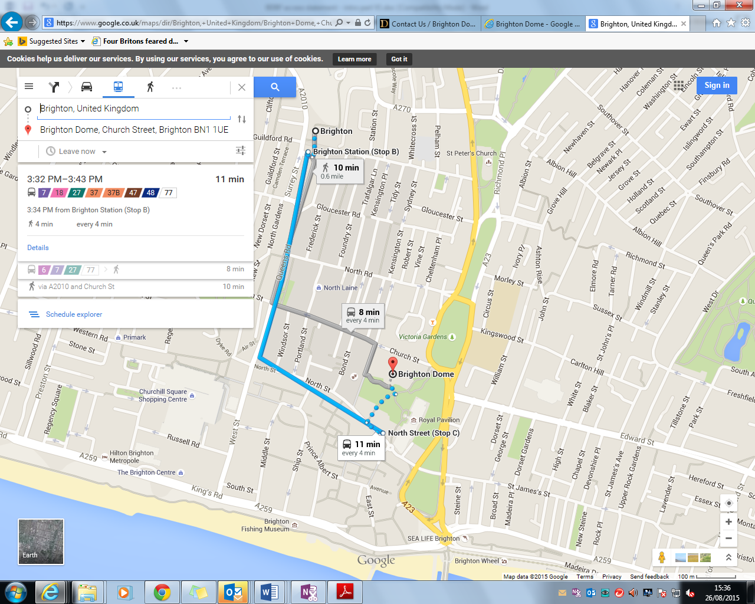

Map of bus route to North Street for Brighton Station

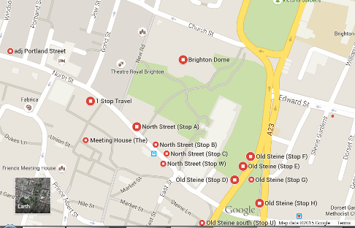

Map of bus stops near Brighton Dome

Driving and Parking
On-street parking is very limited, but possible after 6pm and on Sundays. There are a number of car parks nearby.

The most convenient car park for the Brighton Dome is the NCP Brighton Theatre Car Park, this car park is 200 metres which is a 4 minute walk to the venues.

Address: NCP Brighton Theatre, Church St, Brighton BN1 1US
Tel: 0345 050 7080

- There are 6 blue badge parking bays on ground level (total 587 bays in the whole car park) and there is good lighting throughout.
- There is level access on the entire route to our venues, you will need to cross 3 minor roads which have dropped kerbs, 2 with one-way traffic, the other has mixed traffic and pedestrians. This car park is often manned during busy show times or you can press the call button on the payment machines or barriers for help.
- Offers and discounts are available, please see our website for more information
http://brightondome.org/your_visit/getting_here/
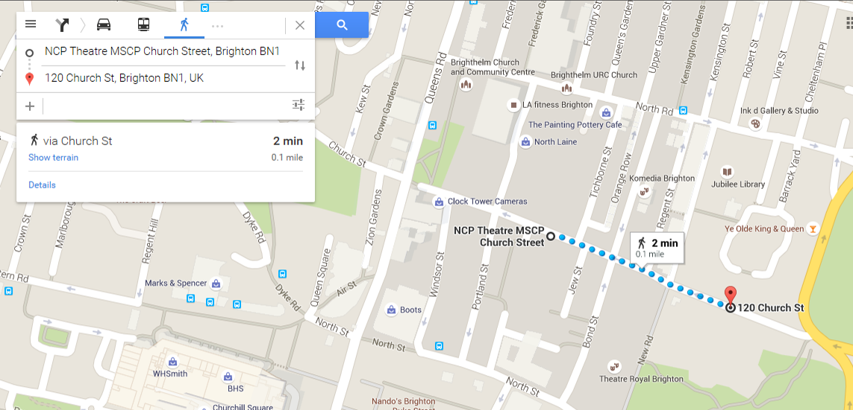

NCP car park route to Brighton Dome

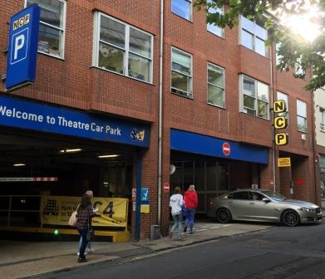

NCP car park entrance on Church Street

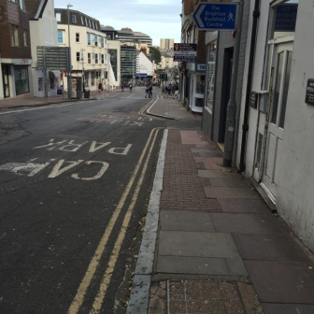

View from NCP car park road down to Brighton Dome

Blue Badge Parking Bays and drop off

There are lay-bys in front of the Concert Hall and Corn Exchange which make good drop off points. Please contact the Visit Services team for more information.

There is no onsite parking available for customers of Brighton Dome, however, there are a limited number of public disabled bays allocated for blue badge holders in the following places near to the venue.

Parking Bays Without time-limit - see map on following page
A
4 at the bottom of Church Street (just before the Dome Concert Hall on the opposite side).

1 in Regent Street (second right after the Dome Concert Hall on Church Street)
B

1 in North Place behind the Prince Regent Swimming Pool (access from North Road)
C

1 in Gardner Street (access from North Road)
D

Blue Badge holders may also park for free in Pay and Display bays with no time limit but NOT in Residents Permit-only parking bays.

Parking bays With 3h time limit (no return within 1h) - see map on following page
E
4 opposite the Studio Theatre in New Road (take first left after the Dome Concert Hall on Church Street). These are marked by metal symbols inlaid into the granite.
F
6 in Jubilee Street (take first right after the Dome Concert Hall on Church Street)

Blue badge holders may park on single and double yellow lines for up to 3 hours (there are common sense limitations on this related to safety, access for emergency vehicles, suspension of bays, other parking signage and road markings etc).

Blue badge holders may NOT park in the loading bays in Church Street.

Map below of Blue badge holder parking bays near Brighton Dome – see previous page for details and map key

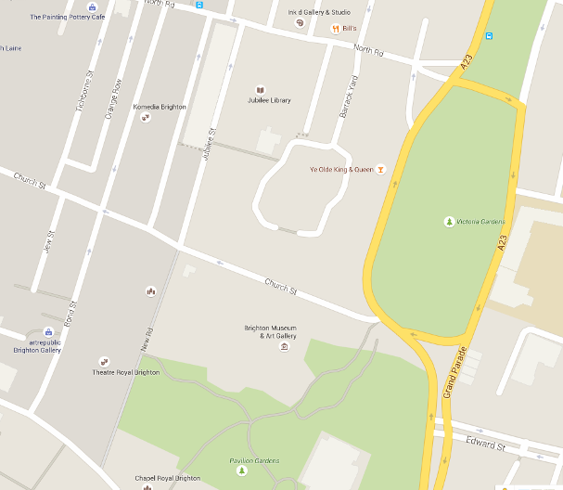
E
F
C
D
A
B
Brighton Dome
Concert Hall, Corn Exchange and Studio Theatre

By Taxi or transport

All of the below companies have accessible taxis in their fleets: If you need to book a taxi from one of our venues please do ask a member of our FOH team who will happily assist you.

Brighton and Hove Radio Cabs:
Web: www.brightontaxis.com,
Email: admin@brightontaxis.com
Tel: 01273 204060

Brighton and Hove City Cabs:
Web: www.205205.com
Tel: 01273 205205
Text: 07528 964384

Brighton and Hove Streamline Taxis:
Web: www.streamlinetaxis.org
Email: operations@streamlinetaxis.org
Tel: 01273 202020

Shopmobility
Brighton and Hove Shopmobility is a scheme that provides wheelchairs, electric mobility scooters and powered wheelchairs to members of the public with mobility issues.
The scheme is run by the award winning Federation of Disabled People and enables people with mobility issues to have the freedom to travel anywhere within the Brighton and Hove area.

Federation of Disabled People
Web: http://www.thefedonline.org.uk/shopmobility
Email: shopmobility@thefedonline.org.uk
Tel: 01273 32 32 39
Open hours - Monday to Friday, 10am – 4pm. Times may vary during autumn/winter months.

