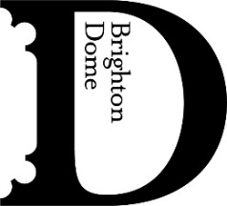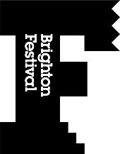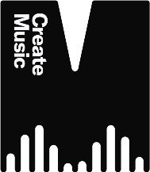

PRESS RELEASE - UNDER EMBARGO UNTIL TUES 11TH NOVEMBER 2025
Brighton Festival Children’s Parade celebrates 40 years and announces theme for 2026

- Theme for this year’s Children’s Parade, produced by Same Sky is inspired by National Year of Reading
- Parade celebrates 40 years of youth creativity in the city
- Full programme for Brighton Festival 2026 to be announced this February

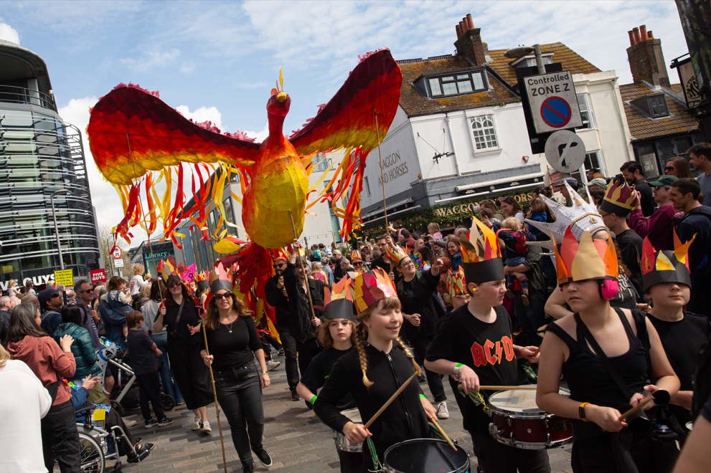
Children’s Parade 2025, credit Jamie Macmillan
Brighton Festival has announced that the theme for the Children’s Parade next May will be Read all about it!

Inspired by 2026 as the National Year of Reading, the theme will explore six genres of Children’s books: Realistic Fiction, Historical Fiction, Fantasy, Traditional Stories, Science Fiction and Graphic Novels & Picture Books.

Jointly produced with award-winning community arts charity Same Sky, the Children’s Parade officially marks the opening of Brighton Festival, a three-week celebration of arts and culture across Brighton, Hove and East Sussex taking place 2-25 May 2026.

The family-friendly, free event takes place in central Brighton, delighting thousands of participants and spectators, and is the largest parade of its kind in Europe. Hundreds of teachers from participating schools across Brighton & Hove will work with their pupils to create large-scale artworks and costumes to display throughout the Parade’s route and support children to learn through making.

2026 marks the 40th Children’s Parade. It’s been estimated that more than 150,000 people have taken part since the parade began in 1986. This year a dedicated Same Sky artist will work with each participating school, including an in-person visit, giving local children the opportunity to learn from a professional artist.

Same Sky are also introducing new ways to support teachers, including – in partnership with Create Music – offering samba masterclasses with Percussion expert Ollie Tunmer (former cast member of STOMP), to help teachers incorporate live music into the parade.

Lucy Davies, Chief Executive, Brighton Dome & Brighton Festival says:
“The Children’s Parade is part of Brighton’s identity – a vivid, collective, public act of imagination and ambition that unites schools, families and communities across the city. As we mark an incredible 40 years, this year’s theme puts storytelling at the centre. This celebration belongs to the city, and we’re so proud to help bring it to our streets again.”

Jane McMorrow, Interim CEO at Same Sky says:
“We’re incredibly proud to mark 40 years of the Children’s Parade – a creative tradition that brings the whole city together. With this year’s theme of children’s literature, pupils and teachers will have the opportunity to let imaginations run wild. We can’t wait.”

The Children’s Parade 2026 will be supported by independent school Brighton Girls, noted for its innovative teaching and commitment to social responsibility.

ENDS

Notes to Editors

THE FULL BRIGHTON FESTIVAL PROGRAMME, WHICH RUNS FROM SAT 2-MON 25 MAY 2026, WILL BE ANNOUNCED BY THE RENEWED LEADERSHIP TEAM ON WED 18 FEBRUARY NEXT YEAR.

BRIGHTON FESTIVAL MEMBERSHIP OFFERS PRIORITY BOOKING FOR ALL PERFORMANCES IN THE FESTIVAL - DETAILS ON HOW TO SIGN UP CAN BE FOUND HERE brightonfestival.org/support-us/
Brighton Festival’s programming team, led by CEO Lucy Davies will announce the full programme for its 60th edition on Wed 18 February 2026. Packed with exciting performances from across the globe and cultural spectrum, the Festival promises a range of new and thrilling experiences for Brighton Festival regulars and newcomers too. As we announce the return of the brilliant Children’s Parade for its 40th year opening the Festival on Sat 2 May 2026, we encourage audiences to sign up to Brighton Festival’s mailing list and join as a member to enjoy priority booking and other special benefits. Information on signing up can be found at brightonfestival.org

For more information, please contact:

Tallulah Morris, Communications Manager – tallulah.morris@brightondome.org
Ben Chamberlain, Bread & Butter PR – ben@breadandbutterpr.uk

Dropbox image link: https://tinyurl.com/tnmx8mmw

About Brighton Dome & Brighton Festival
Brighton Dome & Brighton Festival is a creative charity that produces a year-round programme of music, comedy, theatre, dance, literature, conferences and events across three venues - the Concert Hall, Corn Exchange and Studio Theatre. We produce Brighton Festival, England’s largest multi-arts international Festival, over three weeks every May and are the home for Create Music, which provides music tuition and opportunities to over 30,000 children in over 500 schools across the whole of Sussex.

Located on the Royal Pavilion Estate, Brighton Dome’s venues have a rich history spanning over 200 years, providing extraordinary spaces for artists and audiences. A major capital refurbishment project to restore and protect the Grade I and Grade II listed Corn Exchange and Studio Theatre was completed in 2023, equipping these spaces for a sustainable future.

brightondome.org / brightonfestival.org / createmusic.org.uk
Twitter: @brightdome, @brightfest, @createmusicUK, @FCreatorsUK
Instagram: @brighton_dome, @brightonfestival, @createmusicuk, @futurecreatorsuk
Facebook: brightondome, Brighton Festival, createmusic, futurecreatorsuk

About Same Sky

Same Sky is an award-winning community arts charity, working with people to create luminous parades, showcases, imaginative concepts and community gatherings.

Same Sky creates spectacular street events, including the annual Burning the Clocks and Brighton Festival Children's Parade. ​ Across the UK, the Brighton-based charity brings people together through inclusive art. ​

Strengthening communities, celebrating belonging and inspiring moments of magic.​

Same Sky's Associate Artists are leaders in their field creating original, extraordinary art works that transform places & bring communities together.

​The charity works directly with schools, local authorities, festivals, businesses and community groups to empower individuals and develop creative skills.​

samesky.co.uk

Instagram: @sameskybtn
Facebook: @sameskybtn

