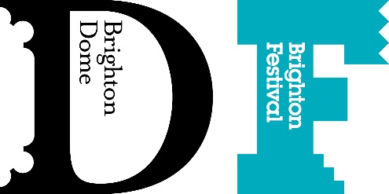

Pledge form
Leaving a gift in your will
Thank you so much for thinking about leaving a gift in your will to Brighton Dome, Brighton Festival and Create Music.
We would be delighted if you would take a few moments to complete this short form and send back to us.
Please tick one of these three statements below:
- I have included a gift to Brighton Dome and Brighton Festival in my will and am happy to talk to you about it
- I have included a gift in my will to Brighton Dome and Brighton Festival but would prefer not to talk to you about it
- I am considering leaving a gift in my will to Brighton Dome and Brighton Festival and would like to discuss this further with you

Your name:
Your email address:
Your phone number:
If you are happy to tell us what made you decide to leave a gift in your will to Brighton Dome, Brighton Festival and Create Music, please tell us below:

Are you happy for us to share your story above in our publicity campaigns to encourage other people to leave us a gift in their will?
- Yes
- No
If you would like to talk to us about leaving a gift in your will, please get in touch with Dona Crisfield
Email: dona.crisfield@brightondome.org

