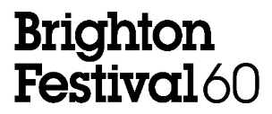

FOR IMMEDIATE RELEASE
Images can be downloaded here
IMAGES RELEASED FROM THE OPENING WEEKEND OF BRIGHTON FESTIVAL 2026

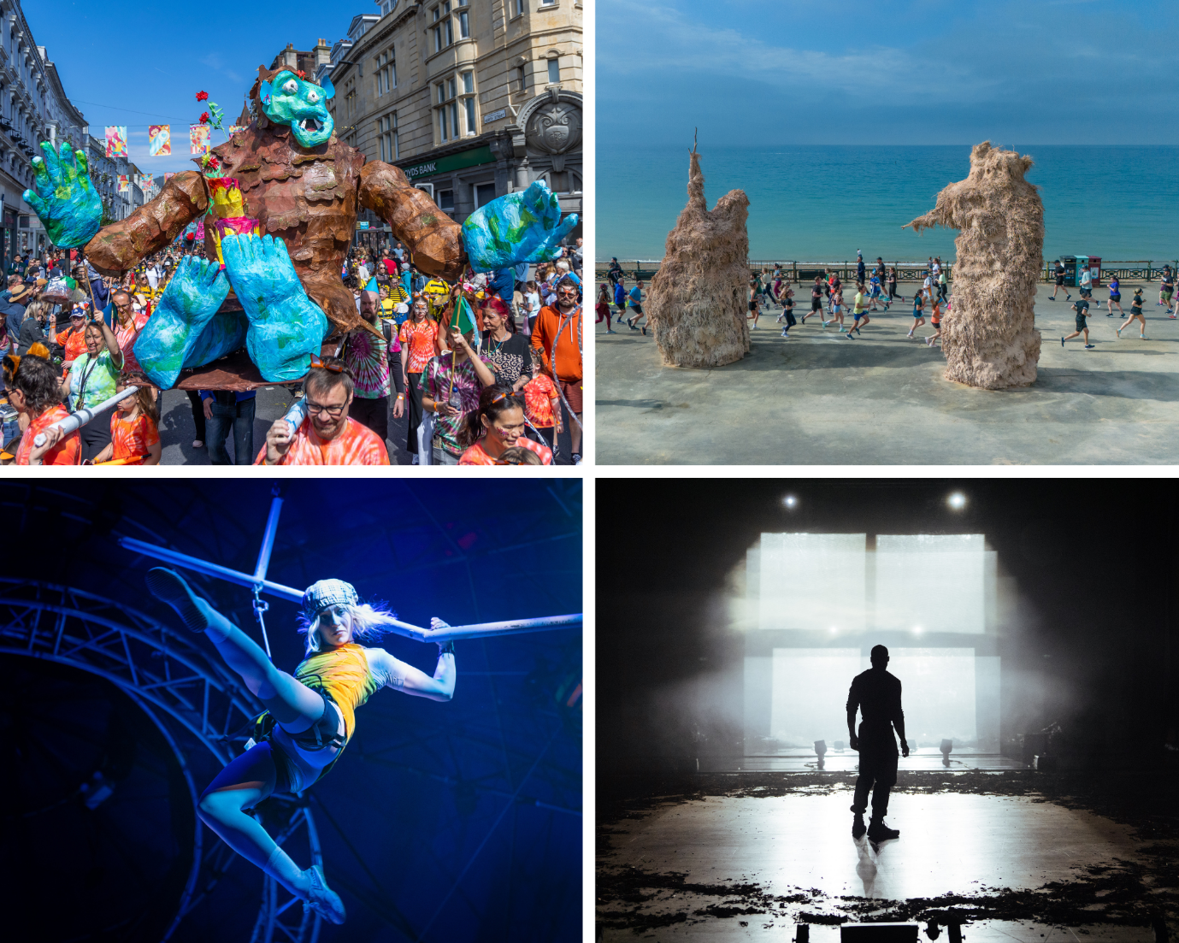
BRIGHTON FESTIVAL 2026 PROGRAMME HIGHLIGHTS AVAILABLE HERE.

Brighton Festival has today released images from the opening weekend of the 60th Edition of England’s largest annual curated multi-arts festival, kick-starting a packed month of activity with over 100 events taking place across the city and surrounding areas until 25 May.

The festival officially opened with the 40th edition of the Children’s Parade, the largest parade of its kind in Europe, which brought together thousands of local people and children in a joyous procession on the theme 'Read all about it!', the world premieres of Soft Machines, a monumental new social artwork on Hove Promenade, carnation by the UK’s leading contemporary circus group NoFit State, Kohlhaas the first theatre production produced by Brighton Festival, and Shhh… by Abigail Norris and Isobel Smith (until 31 May) a new exhibition which explores silence as a charged force, plus the latest works from immersive live-art pioneers KlangHaus.

Weekend highlights also included the 10th edition of Our Place, a free family programme developed by and for the community; music from Beverly Glenn-Copeland, The Age of Consent, Changing Currents and Kneebody, Chiaroscuro Quartet and Consone Quartet, One World Orchestra and AK/DK & Danalogue; a children’s event with author Michael Rosen and MC Grammar; and the exhibition A Timeline of Infinite Skies.

Brighton Festival celebrates the city as a hub for cultural innovation, collaboration and artistic experimentation attracting some of the most exciting artists and companies from all around the world in addition to celebrating and promoting homegrown artists from throughout the region.

Established in the late 1960s, the 60th Edition marks a new era for Brighton Festival under the artistic leadership of new Chief Executive Lucy Davies. This is the first festival to be curated by the Festival Programming team led by Lucy Davies with Producing Director Beth Burgess, enabling the Festival to begin producing original work for the very first time whilst deepening its connection to the city and exploring new partnerships and collaborations both in the South East and internationally.

Presented by Brighton Festival and Same Sky, the annual Children’s Parade, which is inspired by 2026 as the National Year of Reading, saw the streets of Brighton come alive with large-scale artworks and costumes created by hundreds of school children from across the city.

Soft Machines (until 24 May) by Brighton-based artist Ivan Morison and long-term collaborator Heather Peak, in collaboration with Millimetre and Making It Out, sees gigantic, embodied forms made from agricultural materials erected on Hove Promenade in a love letter to Brighton, the city where they first met.

The World Premiere of NoFit State’s carnation (until 25 May, Black Rock), created and directed by Firenza Guidi (Sabotage) combines world class circus, live music and bold cinematic imagery to explore rebellion, resistance and hope in turbulent times.

The World Premiere of Kohlhaas (until 5 May) is the first original theatre work to be produced by Festival Programming team. Directed by Omar Elerian (Bengal Tiger at the Baghdad Zoo, Rhinoceros, Misty) and starring Arinzé Kene (Misty, Girl From The North Country, Get Up Stand Up), this bold and contemporary adaptation of Heinrich von Kleist’s novella Michael Kohlhaas delves into the psychology of protest and resistance.

Shhh... (BN9 Studio, Newhaven) is a sculptural dialogue exploring silence as a charged force. Over two years, artists Isobel Smith and Abigail Norris met weekly, allowing strangeness and intimacy to coexist. The resulting paired works speak for themselves, resonating with tension, pressure and autonomy without merging practices.

Live-art company KlangHaus present two site-responsive, immersive experiences (2 - 23 May, Anita’s Room) which will blend moving images, live music, light, sound-design and staging. Last Haus on Earth dismantles the barriers between performers and audiences in an audio-visual sensorial storm, whilst in Darkroom audiences of six are plunged into darkness in this visceral response to climate change.

The festival theatre programme continues with a 5-hour durational performance by twelve local children and one adult percussionist in Fevered Sleep’s Time Keeps The Drummer (8 - 10 May); Clod Ensemble and Nu Civilisation Orchestra’s live dance celebration of Charles Mingus’ seminal album The Black Saint and the Sinner Lady (16 - 17 May); and fix+foxy’s brutal, immersive, reimagining of the birth of modern America performed by a phenomenal South African cast, Dark Noon (21 - 24 May), the return of the Emma Rice Company with a revival of their hit Malory Towers (19 - 23 May) and the final touring production from The Akram Khan Company, Thikra: Night of Remembering (23 - 24 May).

The visual art line-up also includes an immersive installation and soundscape by artist duo Antonio Jose Guzman and Iva Jankovic A Timeline of Infinite Skies (until 28 June) which reflects on Brighton and Hove’s largely hidden or forgotten legacies resulting from the forced migration of enslaved people.

Global music icons, exclusive collaborations and one-off concerts from critically acclaimed artists, orchestras and ensembles characterise the music programme for Brighton Festival 2026. Patti Smith returns to Brighton Festival for a two-night residency, performing with her long-time collaborators as The Patti Smith Quartet (12 May). In addition, Smith will present an exclusive event for Brighton Festival, An Evening of Words and Music (13 May) which will see the performer, author and visual artist showcasing her spoken word and poetry as she combines it with an intimate live musical performance.

In a UK exclusive especially for the Festival’s 60th edition, pioneering multimedia artist and previous Brighton Festival Guest Director Laurie Anderson presents The Republic of Love (6 May). An immersive multi-sensory experience of song, language and visual art, the show will feature songs from the past that take on new meaning in our current political climate, including Anderson’s Big Science and Language Is A Virus.

The contemporary music line-up also features an exclusive one-off collaboration between groundbreaking artist Sampa The Great and Zamrock pioneers W.I.T.C.H. who will join forces for a night of psychedelic rock, hip-hop and soul, celebrating music born from independence, resilience and creative freedom (9 May); five-time Grammy Award winner and one of the greatest artists in international music, Angélique Kidjo will bring her striking voice and stage presence as part of the Hope Tour (16 May); and a celebration of cult movie La Haine (7 May) with a live soundtrack by Asian Dub Foundation.

In the classical programme, a bold new staging of Bach’s St John Passion (4 May) will take place throughout the Brighton Dome Concert Hall auditorium bringing together the artistry of the Britten Sinfonia, young soloists from Les Arts Florissants, the Brighton Festival Chorus and Youth Choir; countertenor Iestyn Davies and harpist Oliver Wass (20 May) will span 400 years of music from Monteverdi to Anna Meredith in a single concert; international star pianist Denis Kozhukhin performs Beethoven’s Piano Concerto No. 3 with The London Symphony Orchestra under Chief Conductor Sir Antonio Pappano (8 May); the Brighton Philharmonic Orchestra performs Shostakovich’s Symphony No. 10, set to William Kentridge’s animated film Oh To Believe in Another World (17 May), a dream-like “Soviet museum” created using collage, puppets and masked actors.

In the literature programme, Joelle Taylor performs a staged reading of her new poetry collection Maryville (8 - 9 May); a searing, poetic excavation of 50 years of lesbian counterculture, directed by Neil Bartlett with visuals from artist and filmmaker Sweatmother. Taylor will also join award-winning writer Yomi Ṣode and a host of exciting local talent for the return of STATUS FLO (18 May), curated and hosted by AFLO. the poet.

Philippa Perry will discuss her new book Shrink Solves Murder (7 May), and Brighton Festival brings together a group of speakers led by campaigner and founder of HOPE not hate Nick Lowles to respond live to the provocation How to Defeat the Far Right (11 May).

There are over 25 free events taking place during this year’s Festival, including two weekends of free performances from outdoor arts experts Without Walls. Taking place in locations across Brighton and Hove, Weekend Without Walls features nine Festival commissions from UK outdoor artists including; Garbh (womb) an innovative, in-the-round, outdoor dance work that reimagines ancient Gujarati Folk Dance ‘Garba’; Talawa Theatre Company’s Fragments of Us, an intimate exploration of identity, resilience, vulnerability, centring on a cast of Black men and boys; and Nigel ‘Kobby’ Taylor’s The Torch where Afrobeat, hip-hop, rap and storytelling collide in a piece of high-energy gig-theatre.

Brighton Festival 2026 is indebted to the steadfast support of funders Brighton & Hove City Council and Arts Council England; Principal Supporter The Pebble Trust; Major Sponsor Mayo Wynne Baxter; Higher Education Partner University of Sussex; and all sponsors, patrons, members and supporters.

ENDS

Notes to Editors

Images can be accessed here.

The full Brighton Festival press pack can be accessed here:
https://tinyurl.com/bf26presspack

For press enquiries or interview requests please contact:

Katie Fowler, Communications Manager, Brighton Dome & Brighton Festival – katie.fowler@brightondome.org
Alex Jacobs, Communications Officer, Brighton Dome & Brighton Festival – alex.jacobs@brightondome.org

Key facts about Brighton Festival 2026

- 60th edition of Brighton Festival
- 105 events, exhibitions and installations from 1-25 May 2026
- The first-ever Brighton Festival Production, plus another 27 commissions, premieres and exclusives
- The 40th Children’s Parade, and 10th edition of Our Place
- Under 30s can access discounted tickets to over 30 events
- 25 free events, performances and workshops
- 60 performances with tickets £15 or less, plus £10 Festival Standbys for concession groups on most events. The Pay it Forward scheme also supports free ticket vouchers for community organisations.

About Brighton Festival

Brighton Festival was established in 1967 and is the largest annual curated multi-arts festival in England. For three weeks and four weekends each May, it brings a celebration of music, theatre, dance, visual art, film, literature, debate, outdoor and community events to the beautiful Brighton Dome spaces and to familiar and unusual locations in Brighton & Hove and further afield.

Brighton Festival has become one of the city’s most enduring symbols of inventiveness. Renowned for its pioneering spirit and experimental reputation, Brighton Festival’s ambitious, daring programming celebrates its home city as a hub for cultural innovation, collaboration and artistic experimentation and attracts some of the most celebrated and innovative artists and companies from the UK and around the world. Brighton Festival 2026 is its 60th edition and marks the start of a new era, with the first staging of original work produced in-house.

Website: brightonfestival.org
TikTok: @brightonfestival
Instagram: @brightonfestival
Facebook: brightonfestival
X/Twitter: @brightfest

Brighton Festival 2026 supporters

Brighton Festival 2026 is indebted to the steadfast support of funders Brighton & Hove City Council and Arts Council England; Principal Supporter The Pebble Trust; Major Sponsor Mayo Wynne Baxter; Higher Education Partner University of Sussex; and all sponsors, patrons, members and supporters.

Kohlhaas is supported by Louise & Jamie Arnell. The Children’s Parade is supported by Brighton Girls and Jumpin Fun. Soft Machines is supported by the Henry Moore Foundation. Chiaroscuro and Consone Quartets are supported by Margaret Polmear. Comedy and Create Music events and the Brighton Dome & Brighton Festival membership scheme are supported by Mayo Wynne Baxter. Our Place is supported by Pembroke. Michael Rosen & MC Grammar: Ridiculous Raps & Rhymes is supported by Brighton College Prep School. London Symphony Orchestra is supported by Professor David Gann CBE FREng. Festival of Ideas is in collaboration with University of Sussex. Thikra: A Night of Remembering is supported by Dishoom Permit Room.

